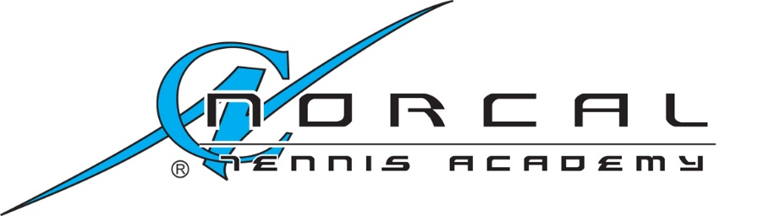

NorCal Athletics, LLC.
dba NorCal Tennis ® Academy
www.NorCalTennisAcademy.com
Email: staff@NorCalTennisAcademy.com
Voice: 1 (408) 896-5745

San Jose, California.

Credit Card Authorization Form

Please complete all fields. You may cancel this authorization at any time by contacting us.
This authorization will remain in effect until cancelled. 3% fee will be added to the total amount.

Credit Card Information
Card Type: ☐ MasterCard ☐ VISA ☐ Discover ☐ AMEX
□ Other
Cardholder Name :
Card Number:
Card Code:
Expiration Date (mm/yy):
Cardholder ZIP Code (billing address):

For Player’s name:

Phone number:

I, , authorize NorCal Athletics, LLC. to charge my credit card above for agreed-upon purchases. I understand that my information will be saved to file for future transactions on my account. For future purchases, an email confirmation will be sent out to me for each time my card being charged and I may notify NorCal Athletics, LLC. to cancel any future charges if needed.

Customer’s Signature Date

